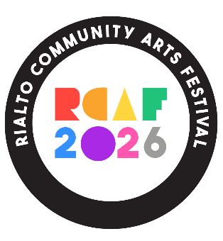
Rialto Community Arts Festival
18-21 June 2026

Volunteer Information/Expression of Interest
Rialto Community Arts Festival (RCAF) is organised by 3 local community projects, and volunteers from the community. The 3 local projects are:
- St Andrew’s Community Centre
- Fatima Groups United/The F2 Centre
- Dolphin House Community Development Association
During the Festival more community volunteers will be needed. Examples of volunteer roles and activities during the Festival are:
- Helping to set up event venues
- Selling raffle tickets at events
- Directing festival attendees to venues
- Helping to clean up after events
Volunteers can give as much time as they want – to one event, or more.
On the last evening of the Festival - Sunday 21st – there will be an end-of-festival event to thank all who worked on it – all Volunteers will be invited.
If you would like to volunteer, please fill in the form on the back of this page and return it to:
Rialto Community Arts Festival, C/O St Andrew’s Community Centre, 468 Sth Circular Rd., Rialto
OR Scan/take a photo of the completed form and email it to:
rialtoartsfest@gmail.com
Maggie Ryan, the Volunteer Co-ordinator, will contact you soon after.

RCAF 2026
Volunteer Expression of Interest

Name: _____________________________________________________________________
Address: ___________________________________________________________________
___________________________________________________________________________
Phone: ____________________________________________________________________
Email: _____________________________________________________________________

Do you have an interest or skills in any particular event or type of activity? ___________________________________________________________________________ ___________________________________________________________________________

Signed: _______________________________________________ Date: ________________

